**CITY OF MADISONVILLE KENTUCKY Payroll Tax Year** End **Return**

1. Total Number of Employees • Taxable Employees Make Check Payable & Mail to:
2. Total Salaries, Wages, Commissions and Other Compensation Director of Finance
3. Less Compensation Paid for Services Outside of Madisonville P.O. Box 1270
4. Taxable Earnings (Line 2 Minus Line 3) Madisonville KY 42431
5. Actual Tax Due in Period at 2.5% **I hereby certify that the information and**
6. Adjustments from Prior Periods **statements contained herein and any schedules**
7. Interest (1% Per Month) After Due Date **or exhibits attached are true and correct.**
8. Penalty (5% Per Month up to 25%, $25 Min.) After Due Date
9. Total Taxes Due Including Interest & Penalty

**"If no wages were paid this period, mark "NONE" and return this form with explanation.** Signed Date

Date Received Check Number Check Amount Account Number For Period Ending **Due On or Before**

Reconciliation of Madisonville License Fee Withheld for Calendar Year is Required.

(If you have 10 or less employees, use the space provided below or furnish copies of employee's W-2. Larger concerns may file on listing (using the format below) or furnish W-2 copies.

**Social Security Number Name of Employee** **Gross Wages Taxable Wages Occupational Tax Withheld**

Attach Continuation Sheet if Necessary

**Tax Year 2025**

# For Quarter Ended March 31, --

For Quarter Ended June 30, --

# For Quarter Ended September 30, --

.

For Quarter Ended December 31, --

**W2's are due by January 31st**

# Total Remitted for the Year

Prepared By Date

--

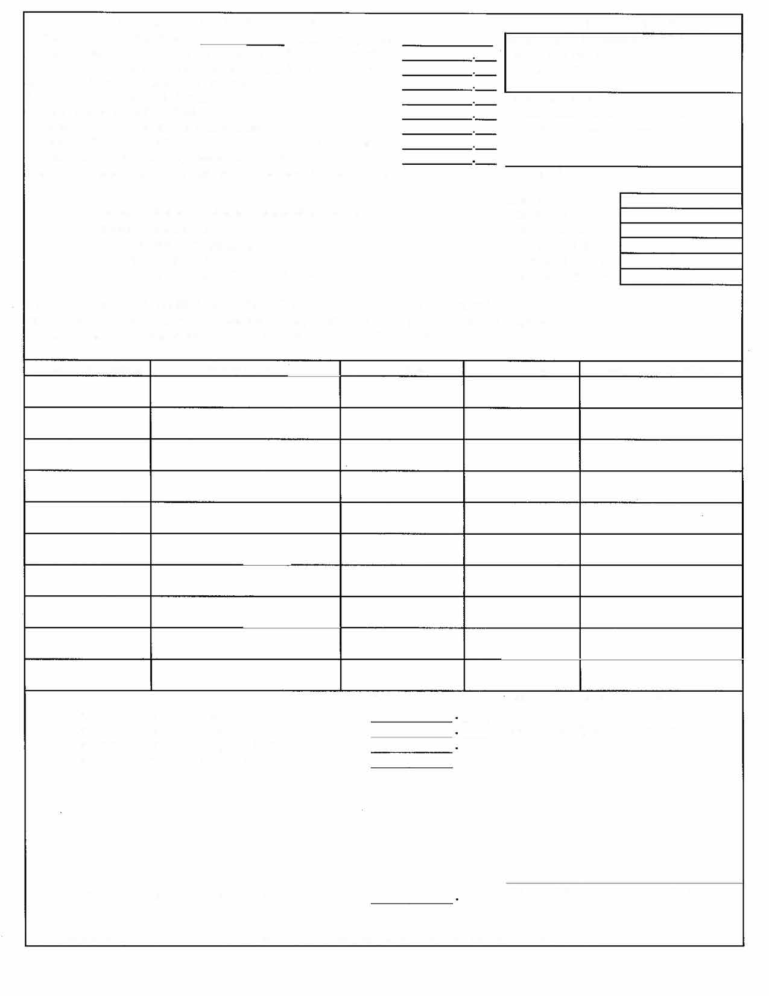

**Notice: This fonn must be returned whether or not you had employees during this period, Wlder Section 110 City Code ofOrdinances.**