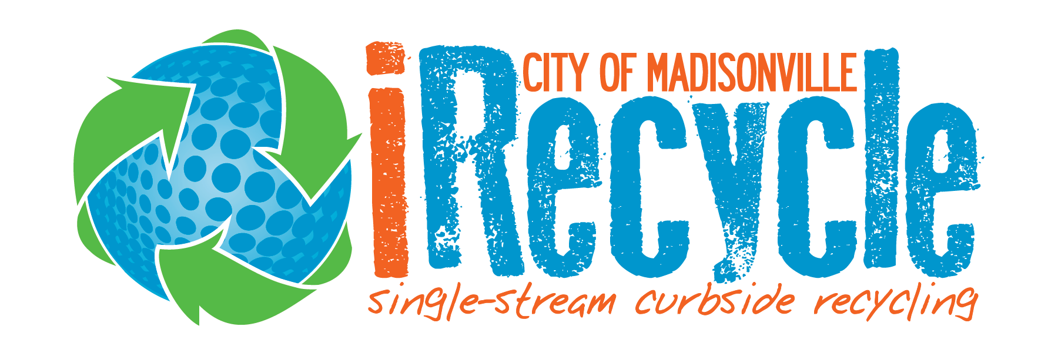
HOW TO ENROLL
Enrollment is easy! If you are currently a City of Madisonville sanitation customer, you are eligible to participate in the iRecycle program. Two ways to register are:
- Email our Sanitation Team at irecycle@madisonvillegov.com with your name, address, and phone number
- Call (270) 824-2117 and we will be delighted to register you. (Remember, our normal hours of operation are M-F, 7:00 a.m. to 3:30 p.m.)
FACTS ABOUT iRECYCLE
- There is no fee to participate. Our Sanitation Department offers this as a service to our community. Participation is voluntary and registering for the program is easy.
- We will deliver a recycling toter to your address. It will look like your trash toter, except the lid will be tan. Toters are typically delivered within two (2) business days of registration.
- The recycling program is single-stream which means our customers do not have to separate the recyclables. (You can help us by only placing recyclables in your recycle toter.)
- Recycle collection is currently every other week. When you call or email, we will provide the pick-up schedule for your specific location.
- When you are ready to start recycling, simply toss all of your recyclables into the toter (no sorting necessary) and roll your toter to the curb by 7 AM on your scheduled collection day. All material collected is sorted and processed at the City of Madisonville Recycling Center. It is then shipped to processing mills.
WHAT CAN GO IN MY RECYCLE TOTER?
- Plastic bottles, jugs & containers; steel, tin, bi-metal & aluminum cans; paper food boxes & containers, newspaper & inserts, magazines, catalogs, paperback books, shredded paper (bagged), envelopes, junk mail, white paper, greeting cards, file folders, aluminum foil & pans, cardboard (max. 3-ft. pieces).
UNACCEPTED RECYCLABLES
- Glass, air filters, hygiene products, hypodermic needles, diapers, and foam products.
IMPORTANT RECYCLING FACTS
- Incinerating 10,000 tons of waste creates one job; landfilling 10,000 tons of wastes creates six jobs; recycling 10,000 tons of waste creates 36 jobs.
- The national recycling rate of 32 percent saves the equivalent of more than five billion gallons of gasoline, thereby reducing our reliance on foreign oil by 114 million barrels.
- According to the U.S. EPA, recycling (including composting) diverted 94 million tons of material away from landfills and incinerators in 2020.
- By recycling aluminum cans at the curbside, not only do we offset expenses of collecting and reprocessing aluminum, but we also contribute to supporting the collection of other recyclable materials. According to a US EPA report, two decades ago, the United States had just one curbside recycling program in operation.

